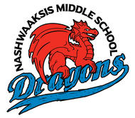
STUDENT ORIENTATION
We would like to invite your
Grade 5 Students
to join us at
Nashwaaksis Middle School
Wednesday, May 8th
From 9AM – 11AM
For Orientation into Grade 6 for
Fall 2019!
We look forward to meeting the future students of NMS!
Thanks!
Kendra Frizzell, Principal
Marcie Connors, Vice Principal

